ITEM DETAILS
Name of Item | Inter-War Flats
Other Name/s  Former Name/s | 181 Hastings Parade, North Bondi
Item type | Built
Item group | Flat Building
Item category | Flat
Area, Group, or Collection Name | Unknown
Street number | 181
Street name | Hastings Parade
Suburb/town | North Bondi |  |  |  |  | Postcode |  |  | 2026
Local Government Area/s | Waverley
Property description | SP 18687
Location - Lat/long | Latitude | -33.891831 |  | Longitude | 151.28472
Location - AMG (if no street address) | Zone |  |  | Easting |  |  |  | Northing
Owner | Private
Current use | Residential
Former Use | Residential
Statement of significance | 181 Hastings Parade North Bondi (c1938-40) is a fine and intact example of an Inter-War Art Deco flat building in a Waverley. It demonstrates the development of the 1881 Queenscliff subdivision in the Inter-War period, following the extension to the tram to North Bondi in 1929. The building represents the development of Inter-War flat buildings, an important phase in the history of Waverley which represents the 1920s-1930s development boom, a prominent period of economic prosperity and speculative development in Waverley associated with the changing demographics with a shift to living in flats.
Level of Significance | National |  | State |  |  |  | Local

DESCRIPTION
Designer

Builder/ maker | John Everitt Bright
Physical Description | 181 Hastings Parade North Bondi is a two-storey freestanding flat building that dates from the Inter-War period, within the key period of significance of the Queenscliff subdivision. The building displays features of the Inter-War Art Deco style including symmetrical form, stepped building mass, stepped parapet, decorative face brickwork, vertical fins, parallel-line motif, and is part of a group. The building is setback 3 metres from the street on a regular site approximately 12 metres wide, that reflects the original subdivision pattern in a suburban setting that has retained much of its historic context. The site has a fence of face brick approximately 0.9 metre high, which compliments the setting of the place. The building appears to be in good condition and is highly intact.  Elements impacting upon the integrity of the site include the ground floor fenestration.
Physical condition  and  Archaeological potential | The building appears to be in good condition
Construction years | Start year | 1938 | Finish year | 1938 | Circa
Modifications and dates

HISTORY
Historical notes | 181 Hastings Parade North Bondi was part of 13 acres 1 rood 9 perches subdivided under DP 689, then resubdivided as Queenscliff Estate DP 786 by Michael Hegarty, James Horan and William John Clarke in 1881. Lots in DP 786 were sold from 1882 (552-91). The site occupies Lot 26 of Section 7 DP 786, which remained unsold in 1887 to 1891. (1032-141) (1770-24). The subject lot and 20 other unsold lots were purchased by Leslie James Lamrock in September 1910 (2094-226). Lot 26 (and eight other lots) were sold to Albert Edward Dalwood in November 1910. (2107-212). Lot 26 was sold in November 1912 to Albert Ray (2344-172). In 1914, Pierre and Johanna Palanque purchased the site. In 1921, Alexander and May McIntosh bought the property, and it changed hands regularly in 1926, 1927, 1928, and 1936. In 1938 the site was purchased by John Everitt Bright of Bondi, a builder. It is likely that the building was constructed at this time. In 1940, Bright sold to Sydney Bath, a Clovelly investor. The 1943 aerial photograph shows the building constructed.

THEMES
National  historical theme | 3 Developing local, regional and national economies  4 Building settlements, towns and cities  8 Developing Australia’s Cultural Life
State  historical theme | Transport  Towns, suburbs and villages  Land tenure  Accommodation  Domestic life
Local  historical theme | Traffic and Transport  Flats and Bungalows  Speculation and Subdivision

Assessment
A: Historical Significance | The site of 181 Hastings Parade North Bondi has historical significance at a local level as it demonstrates the development of the 1881 Queenscliff subdivision in the Inter-War period, following the extension to the tram to North Bondi in 1929.  181 Hastings Parade North Bondi has historical significance at a local level as it represents the development of Inter-War flat buildings, an important phase in the history of Waverley which represents the 1920s-1930s development boom, a prominent period of economic prosperity and speculative development in Waverley associated with the changing demographics with a shift to living in flats.
B: Associative | To date no historic association has been identified.
C: Aesthetic significance | 181 Hastings Parade North Bondi has aesthetic significance at a local level as a fine and intact example of an Inter-War Art Deco flat building in a suburban setting.  The building shows an accomplished use of the Inter-War Art Deco style which features symmetrical form, stepped building mass, stepped parapet, decorative face brickwork, vertical fins, and parallel line motif.
D: Social significance | To date no social cultural, and spiritual significance has been identified.
e) Technical/  Research significance | To date no research/technical significance has been identified.
f) Rarity | To date the research indicates 181 Hastings Parade North Bondi is not rare.
g) Representative-ness | 181 Hastings Parade North Bondi has representative significance at a local level as a fine and intact example of an Inter-War Art Deco flat building in Waverley.
Integrity | The building is highly intact.

HERITAGE LISTINGS
Heritage listing/s | Draft Waverley LEP 2012

INFORMATION SOURCES
Type | Author/Client | Title | Year | Repository
 | Waverley Council | Waverley Heritage Policy | 2007
 | Waverley Council | Waverley Heritage Study | 1993
 | Perumal Murphy Pty Ltd | Waverley Heritage Study | 1990
 |  | Certificate of Title, Vol 1032 Fol141 |  | NSW Land Registry Services
 |  | Certificate of Title, Vol1770 Fol24 |  | NSW Land Registry Services
 |  | Certificate of Title, Vol 2094 Fol226 |  | NSW Land Registry Services
 |  | Certificate of Title, Vol 2107 Fol212 |  | NSW Land Registry Services
 |  | Certificate of Title, Vol 2344 Fol172 |  | NSW Land Registry Services

RECOMMENDATIONS
Recommendations

SOURCE OF THIS INFORMATION
Name of study or report | Heritage Policy by Waverley Council reviewed by Architectural Projects 2023 |  | Year of study or report
Item number in study or report
Author of study or report
Inspected by
NSW Heritage Manual guidelines used? |  |  |  | Yes |  | No
This form completed by |  |  |  | Date

IMAGES

Image caption | 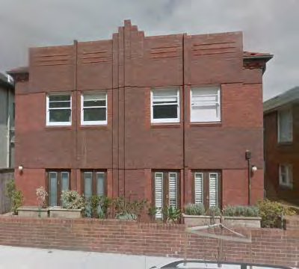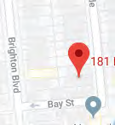
Image year |  | Image by | Google Maps | Image copyright holder

Image caption | 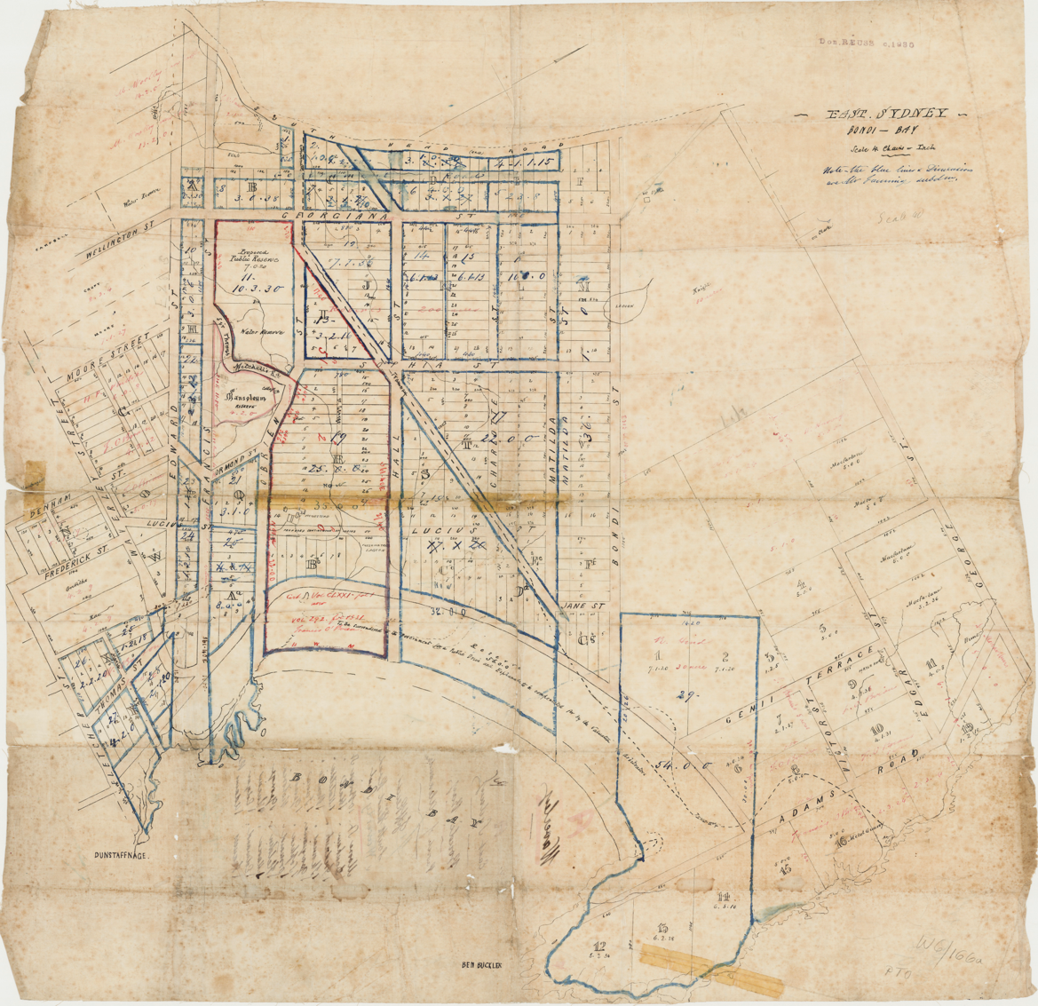
Image year | Undated | Image by | State Library of New South Wales | Image copyright holder

Image caption | 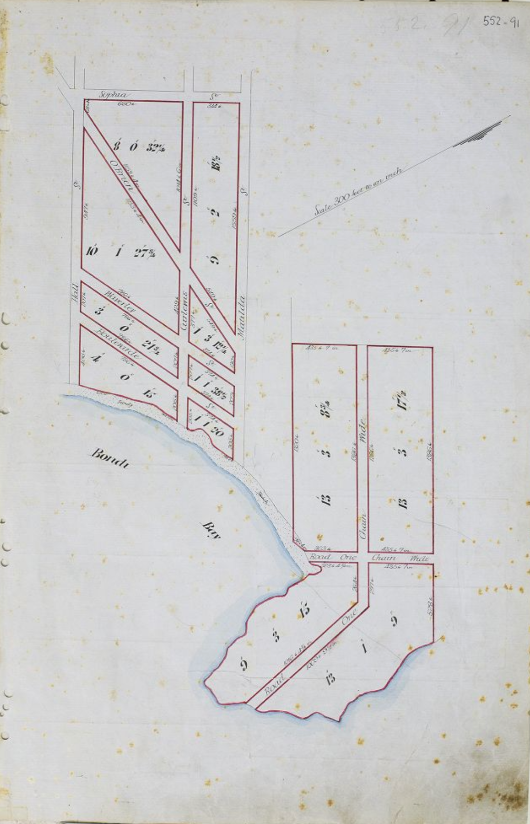
Image year | 1881 | Image by | Historical Land Records Viewer | Image copyright holder

Image caption | 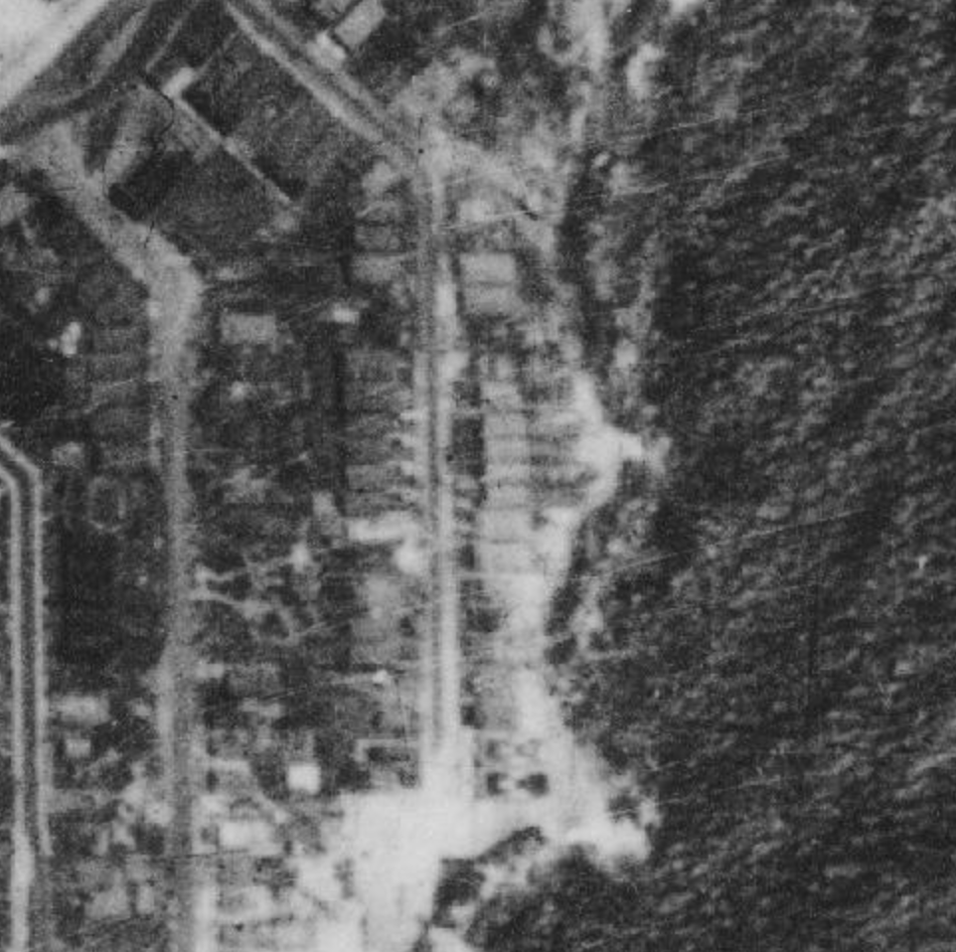
Image year | 1930 | Image by | NSW Historical Imagery | Image copyright holder

Image caption | 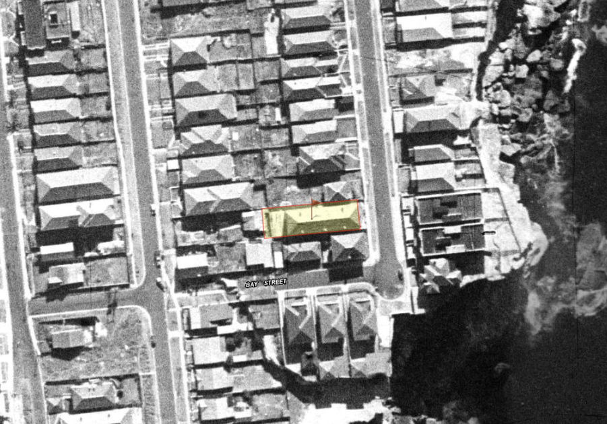
Image year | 1943 | Image by | SIX Maps | Image copyright holder

